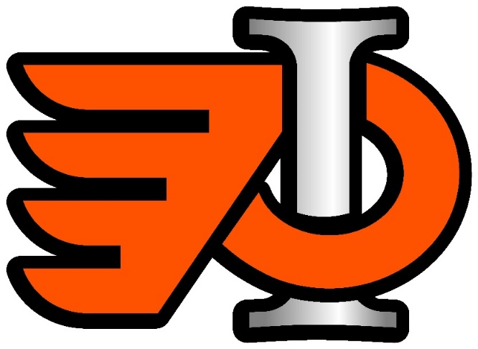
WE NEED YOU!!!

BE A REFEREE!!!
IMHA is looking for individuals 12 – 70 to serve as REFEREE’s for the 2017-2018 Hockey Season. Being a Referee can be a challenging and rewarding way to help children and youth in the community. Hours are flexible and compensation is fair. No direct experience is necessary. There are clinic’s coming to Innisfail on Sunday, September 24 and Sunday, October 15. Please register online for either of the clinics.

To register for a clinic please go to the Hockey Alberta website and under Officials you can register and complete the online course. https://ehockey.hockeycanada.ca/ehockey/ClinicList.aspx?oid=4

For Further Info please email bruce.rafuse@mcman.ca or innisfailminorhockey@gmail.com. Or call Bruce @ 403-350-4431.

